**FACE DETECTION WEBINAR**

**Name: SOUMYA G**

**Mail id:** [**soumya221999@gmail.com**](mailto:soumya221999@gmail.com)

**College: Dayananda Sagar College of Engineering**

* **AWS Login screen with username:**

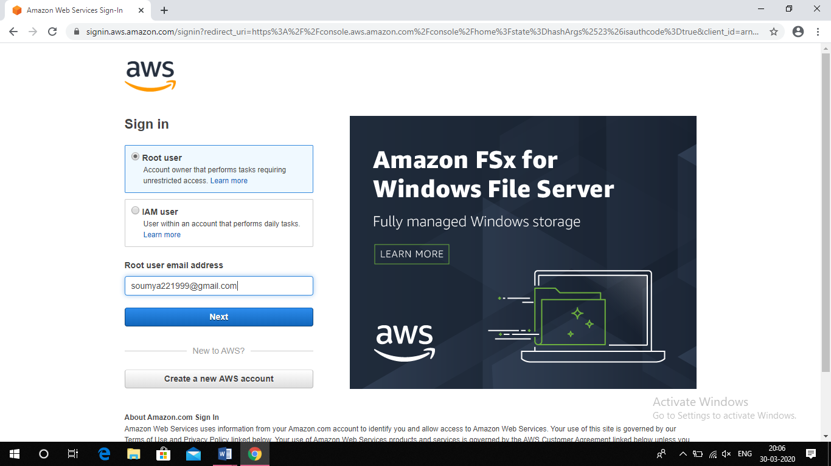

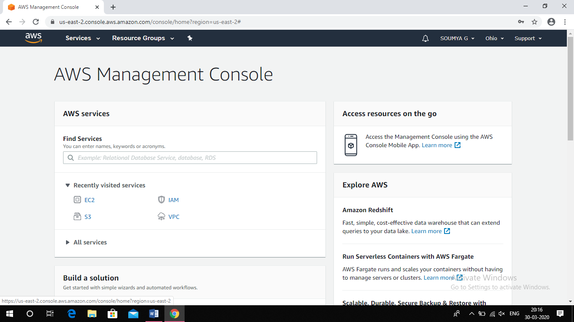

* **EC2 Dashboard:**

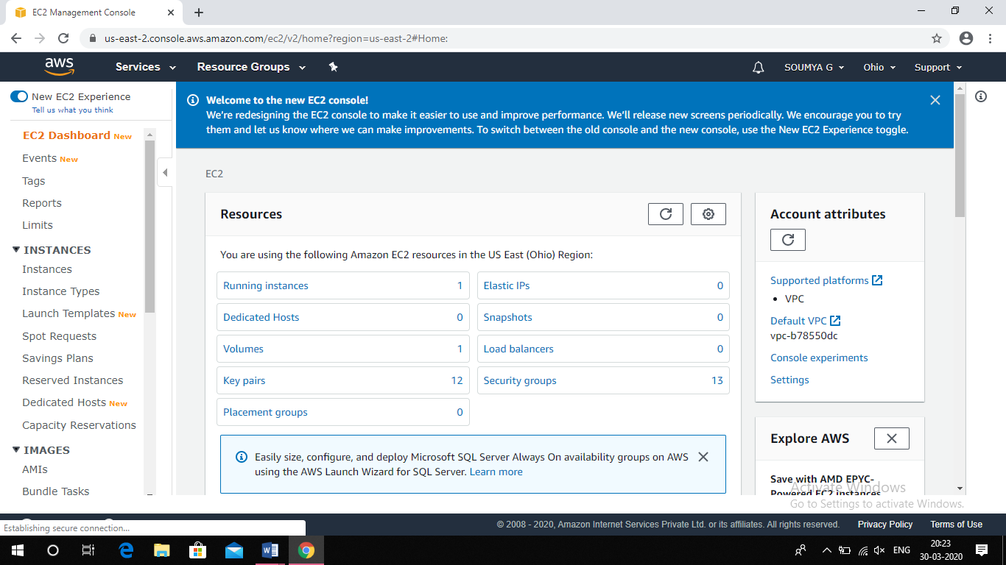

* **S3 Dashboard:**

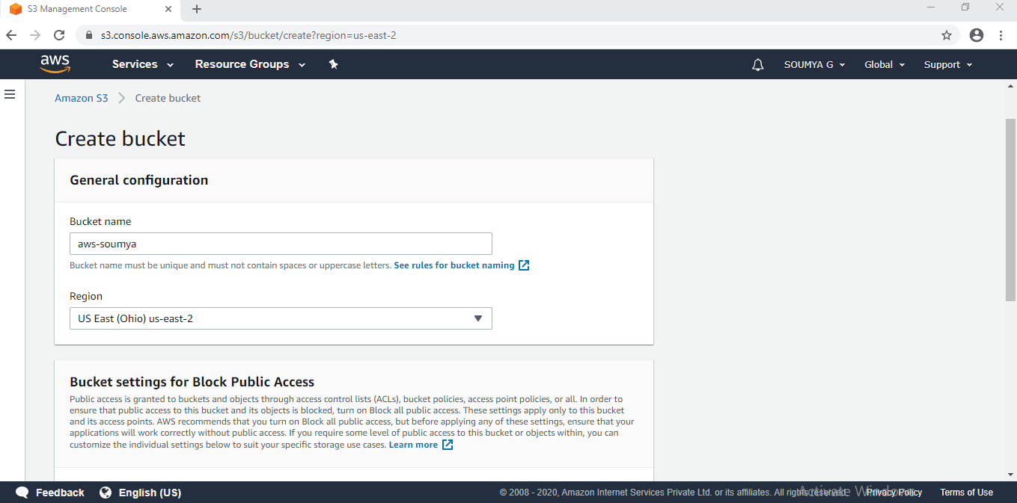

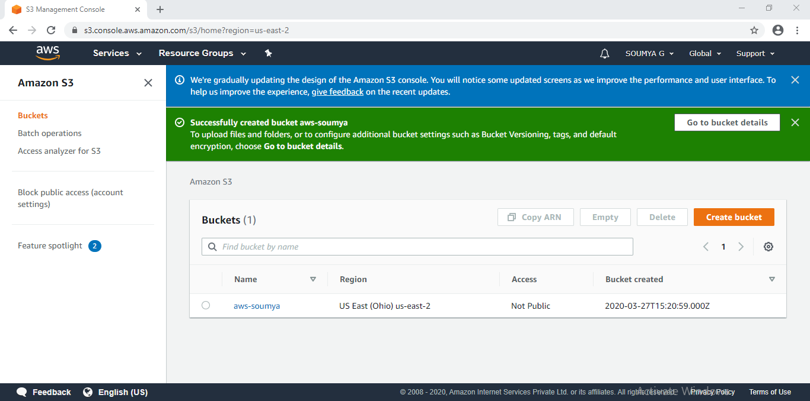

* **Rekognition Dashboard:**

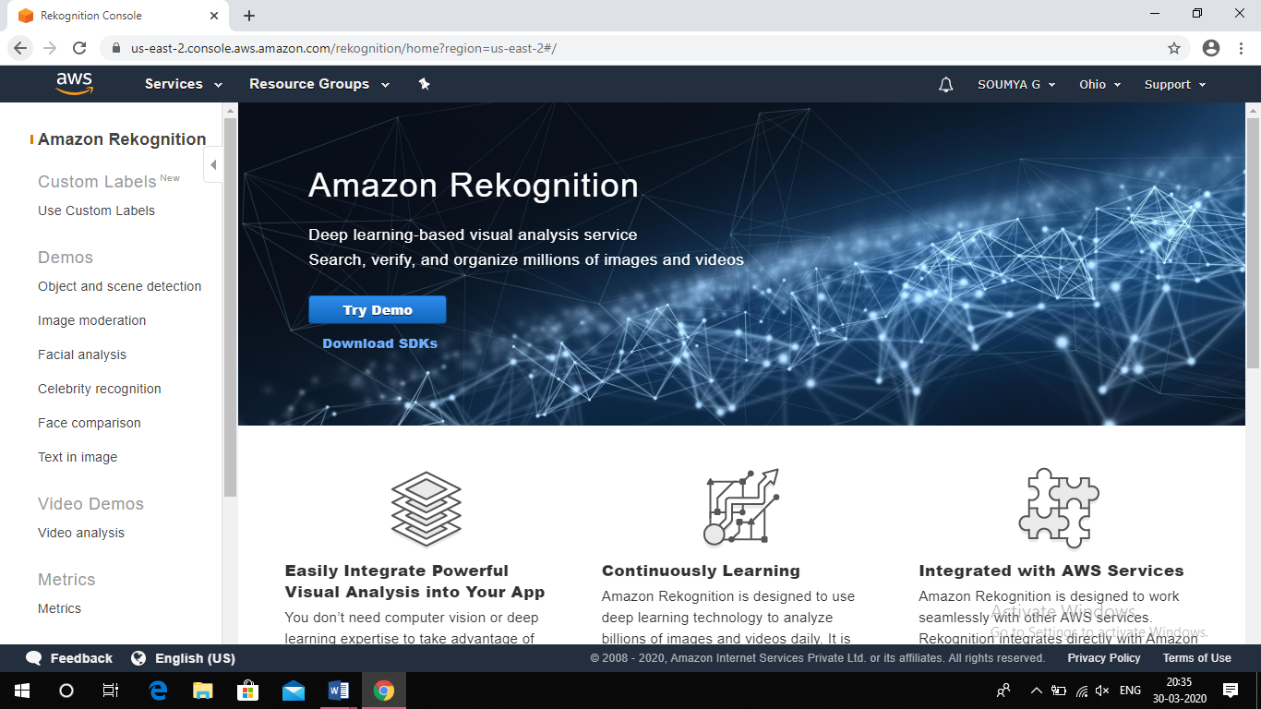

**IN EC2:**

1. **Choosing an AMI:**

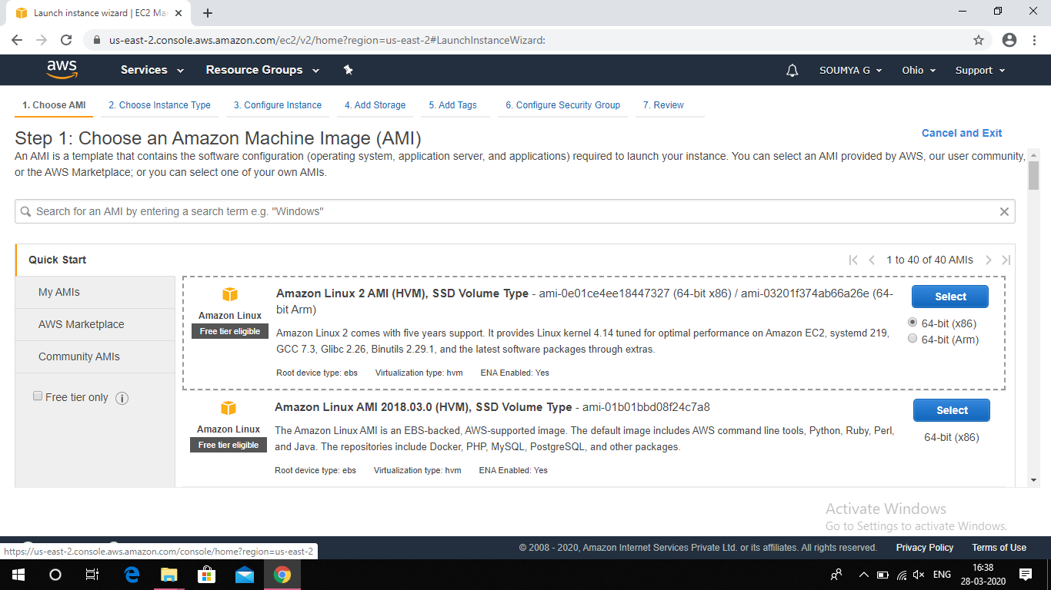

1. **Choosing an Instance Type:**

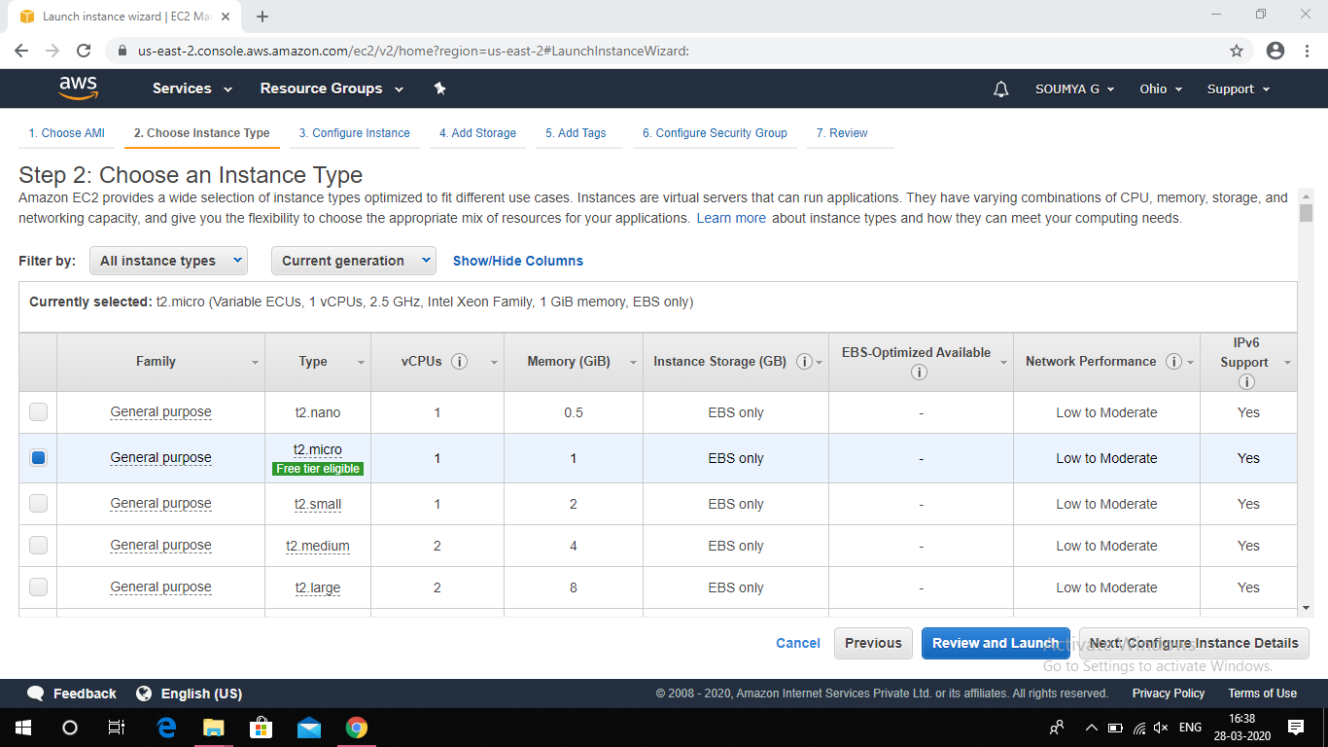

1. **Adding Storage:**

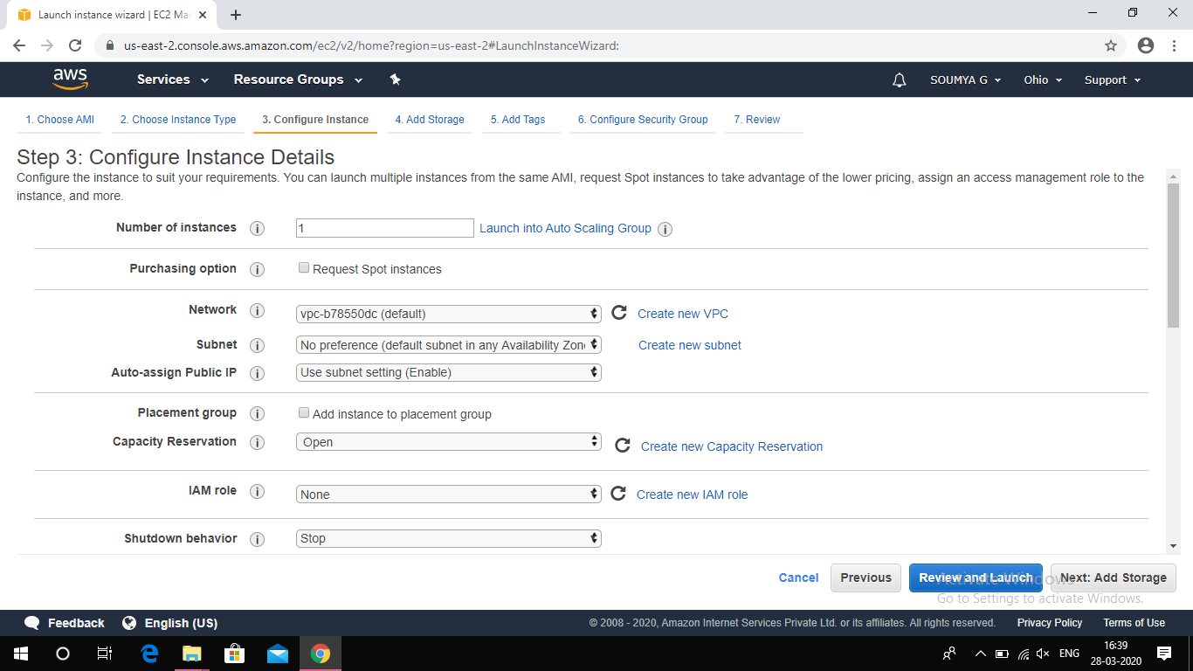

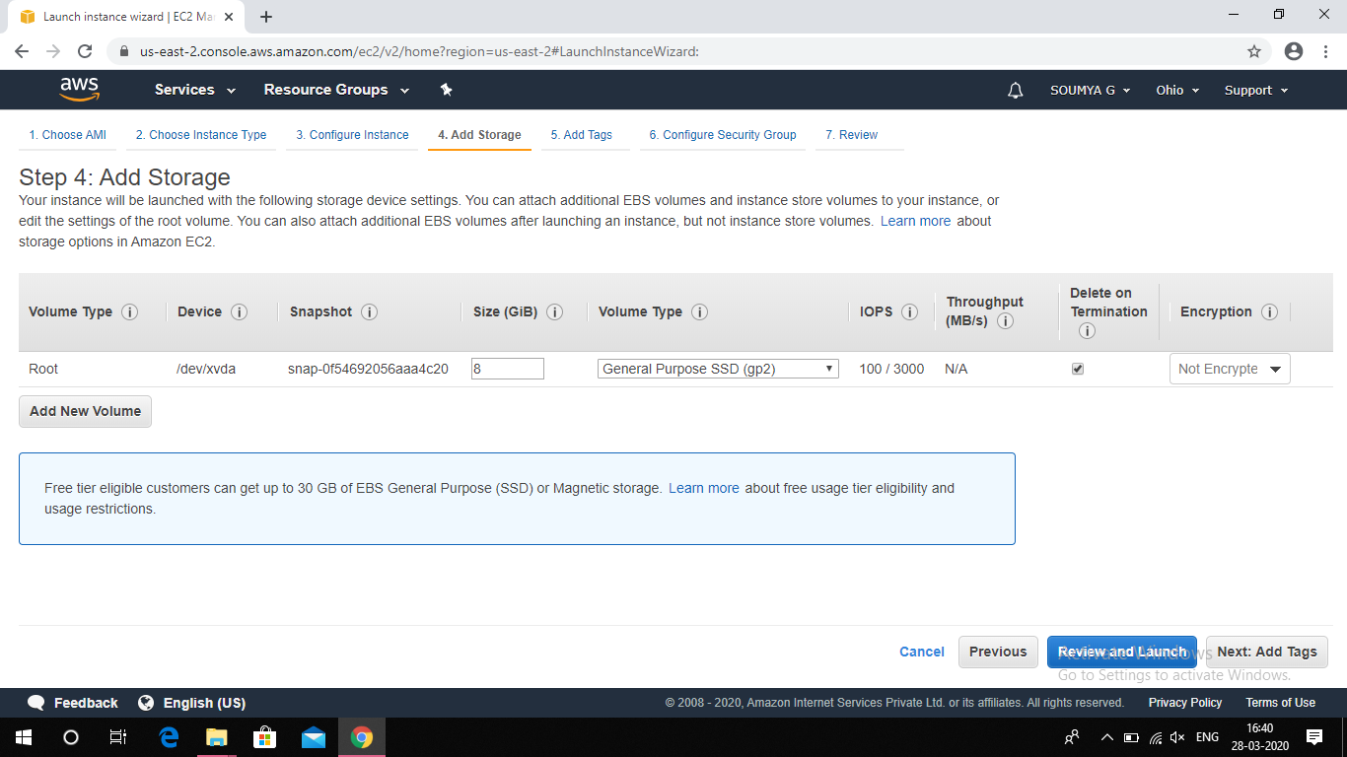

1. **Configuring Security Group:**

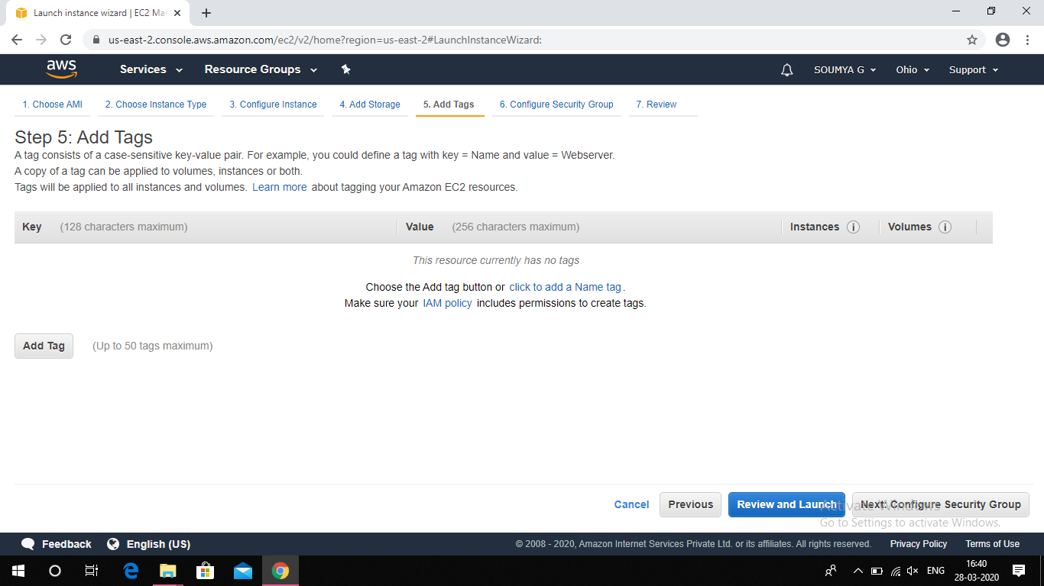

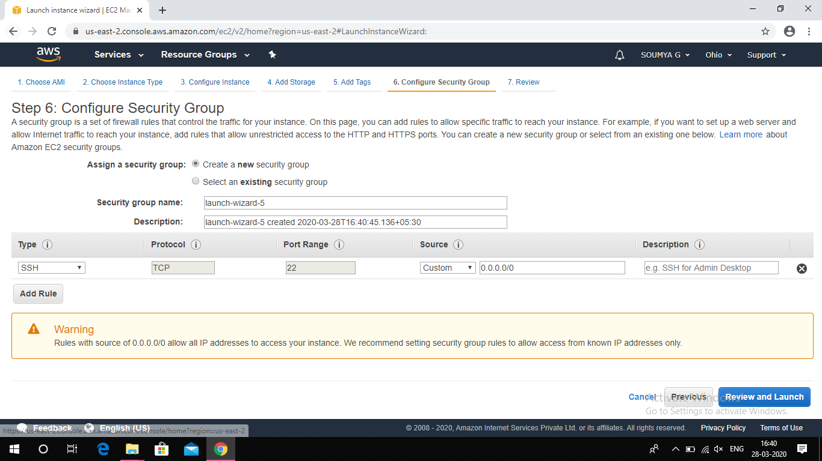

1. **Key pair download:**

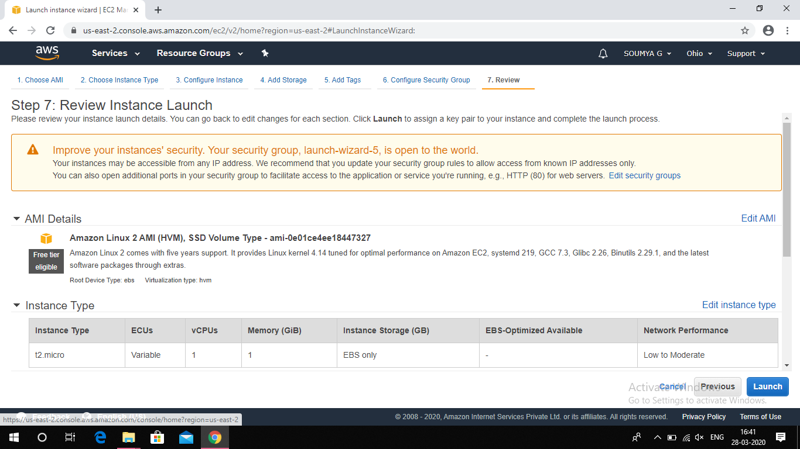

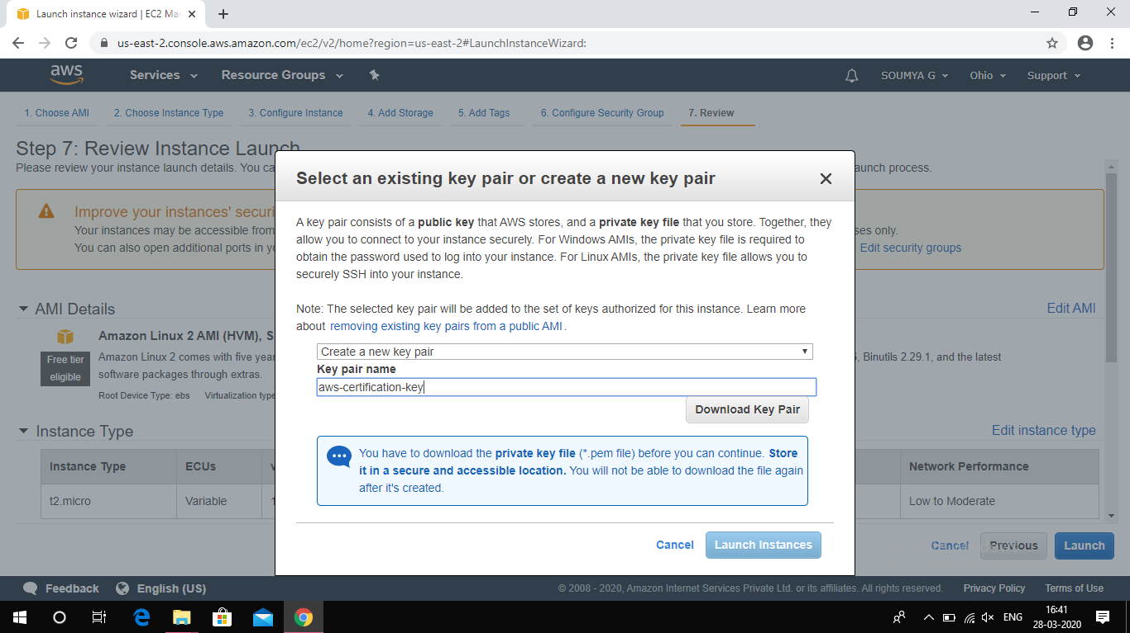

1. **PuTTYgen conversion from pem to ppk:**

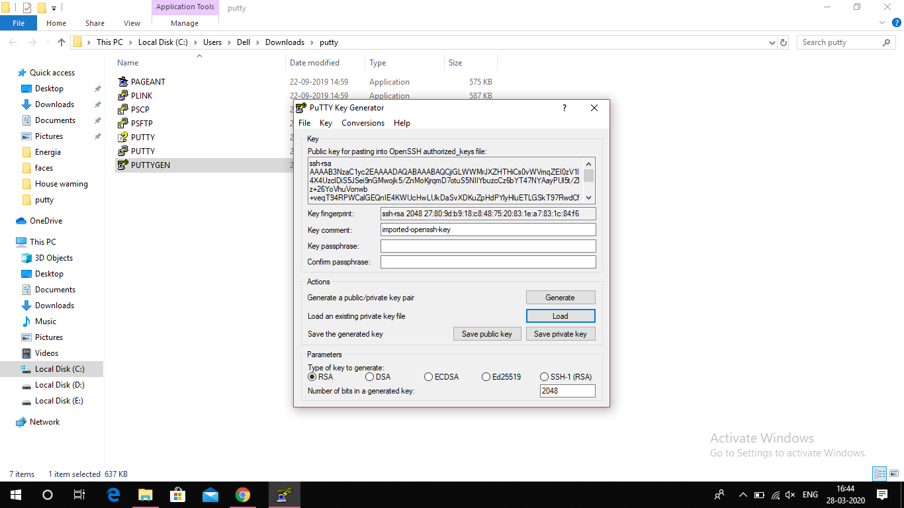

1. **Logged in EC2 black screen:**

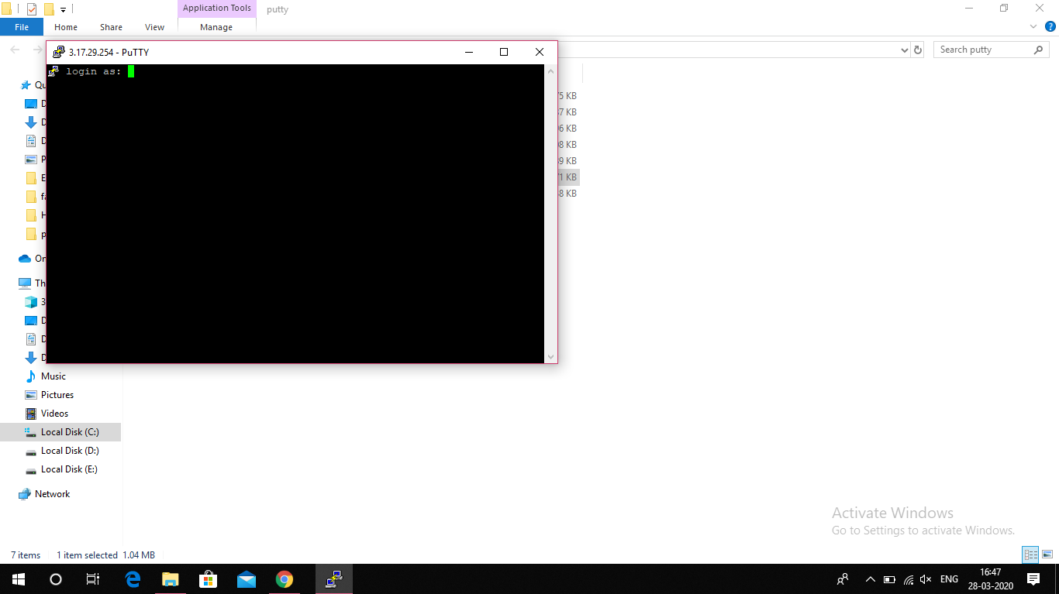

**IN S3:**

1. **Creating a bucket:**



1. **Uploading an Object:**

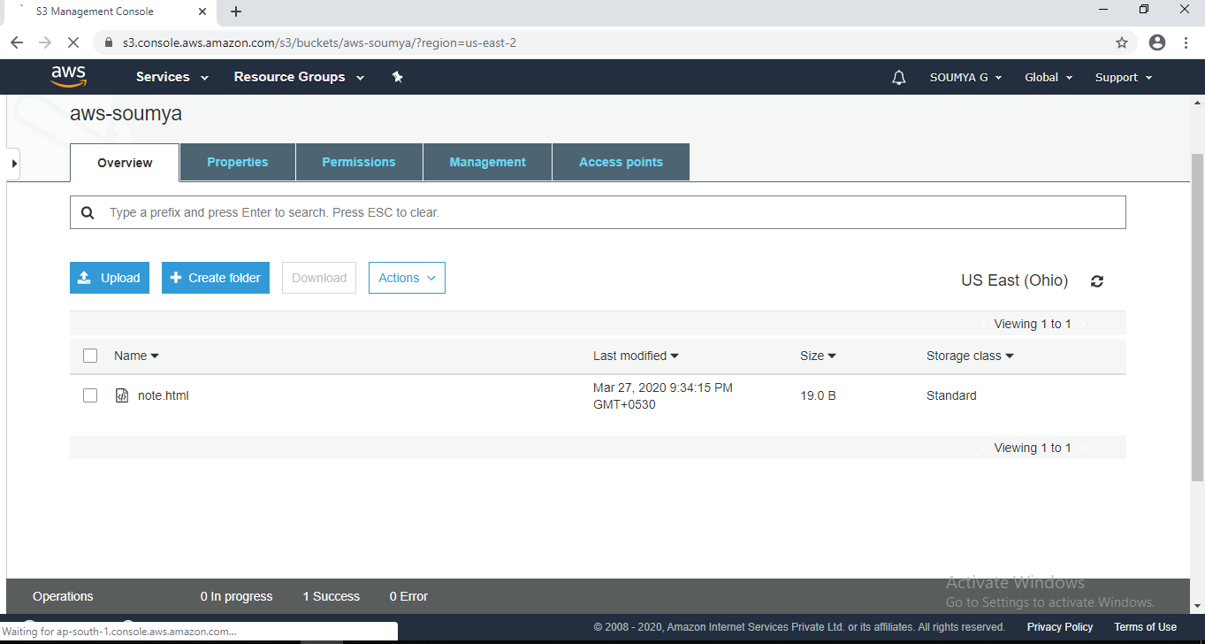

1. **Enabling Static Website:**

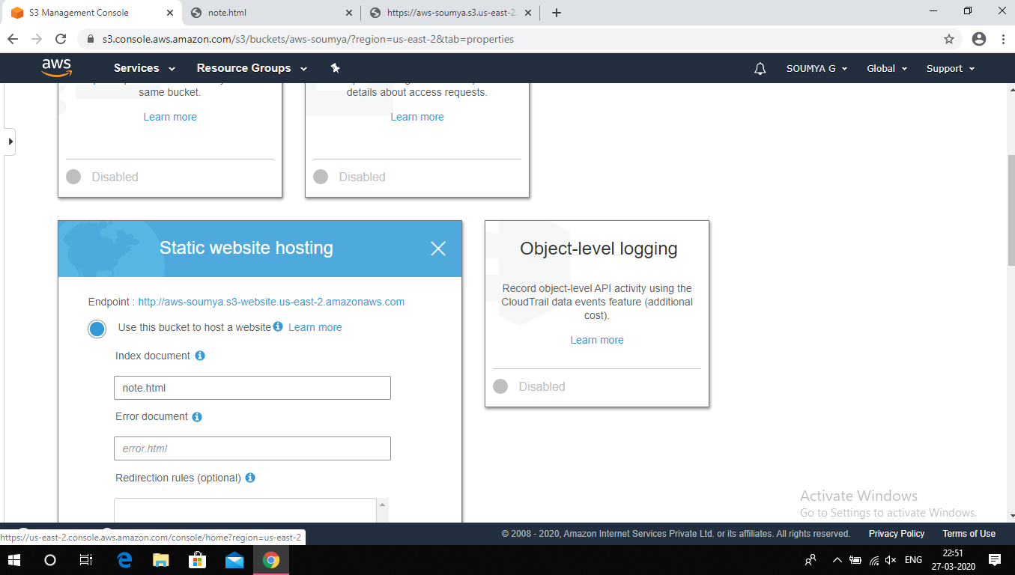

1. **Making the Object public:**

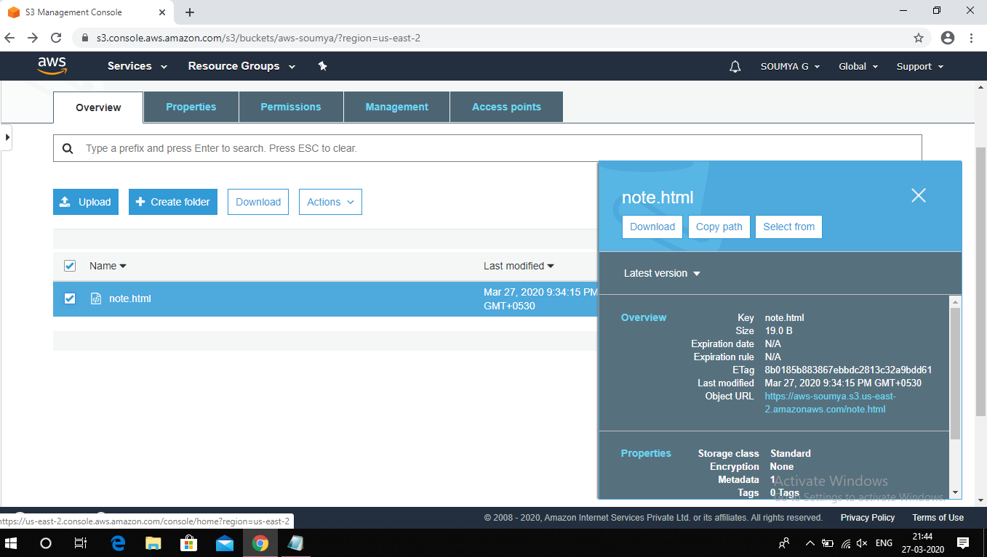

1. **Checking the S3 link on browser:**

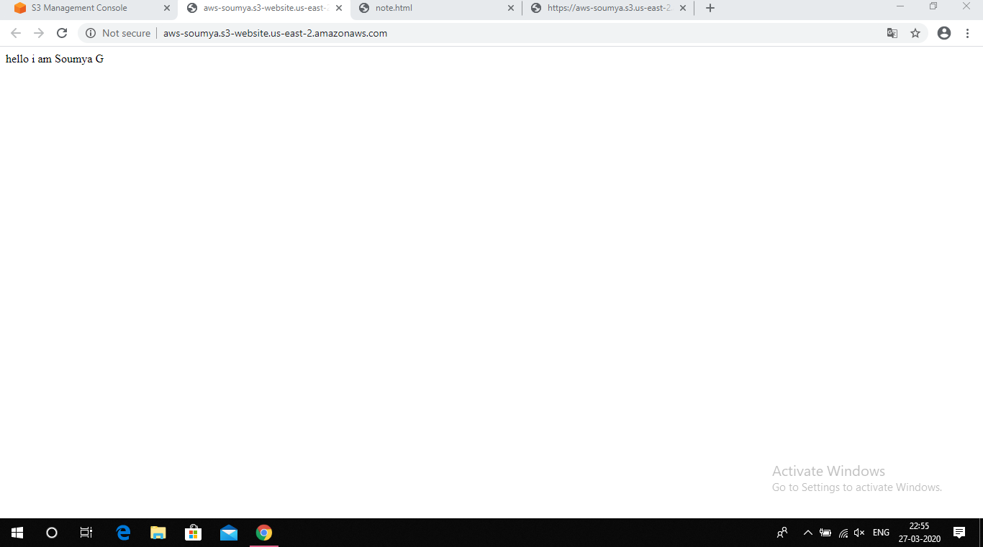

**IN REKOGNITION:**

* **Face detection:**

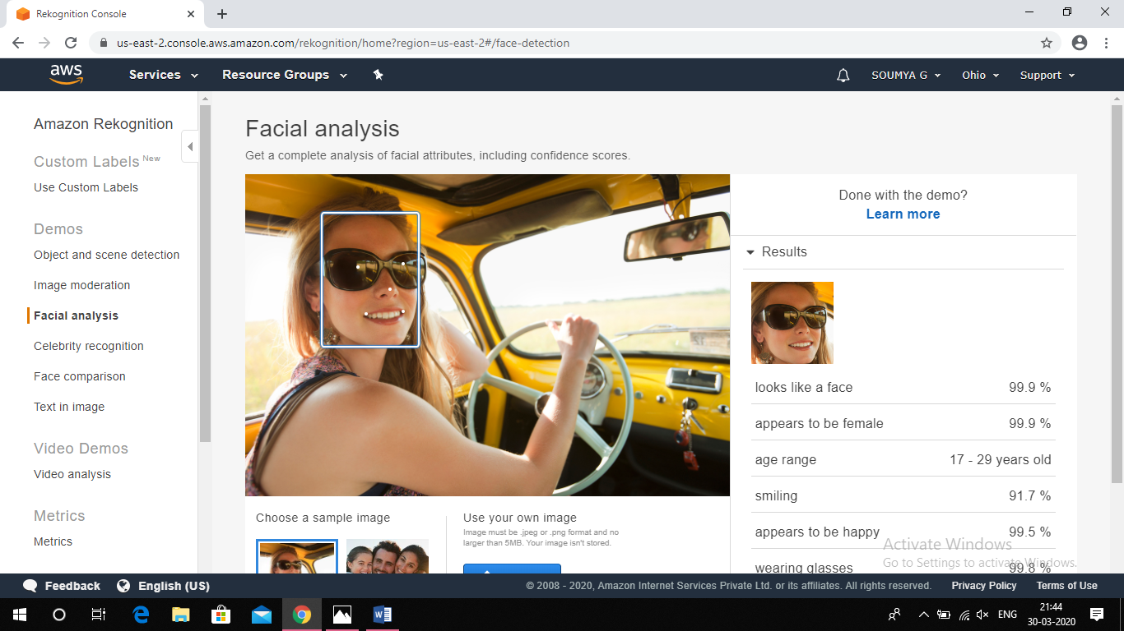

* **Face comparision:**

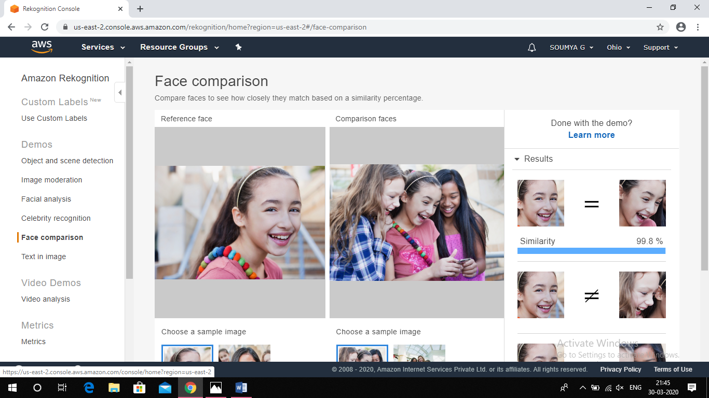

* **Celebrity Recognition:**

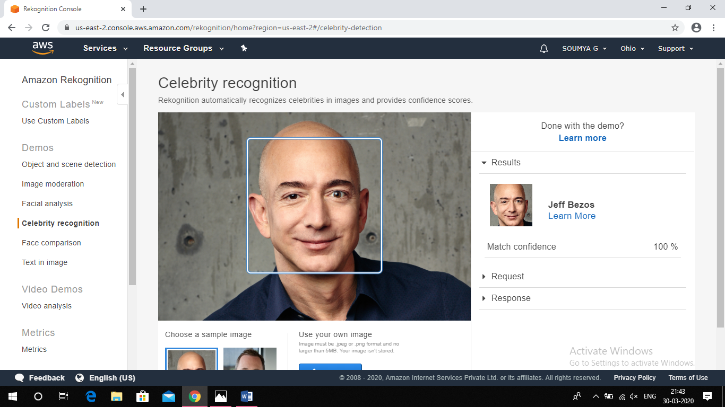

* **Text in Image:**

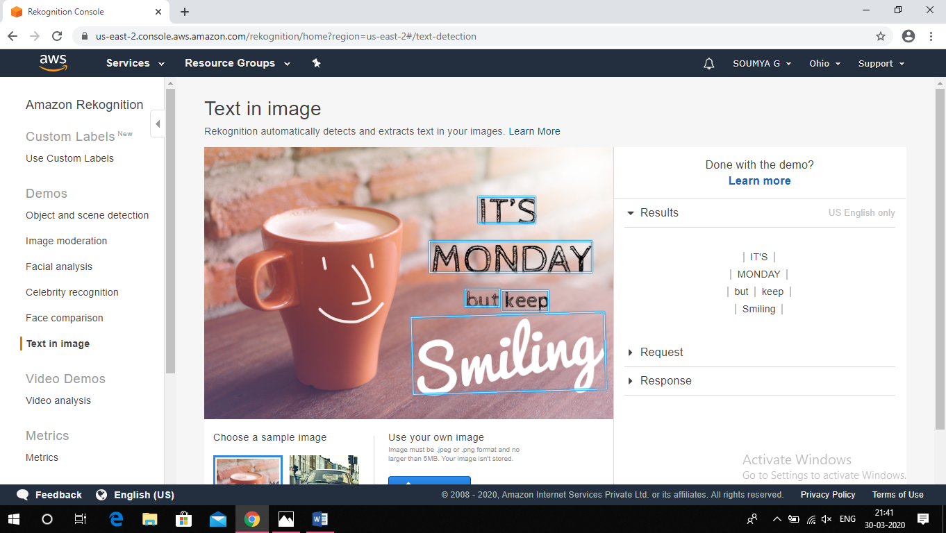

**EC2 & S3:**

* **Installing php :**

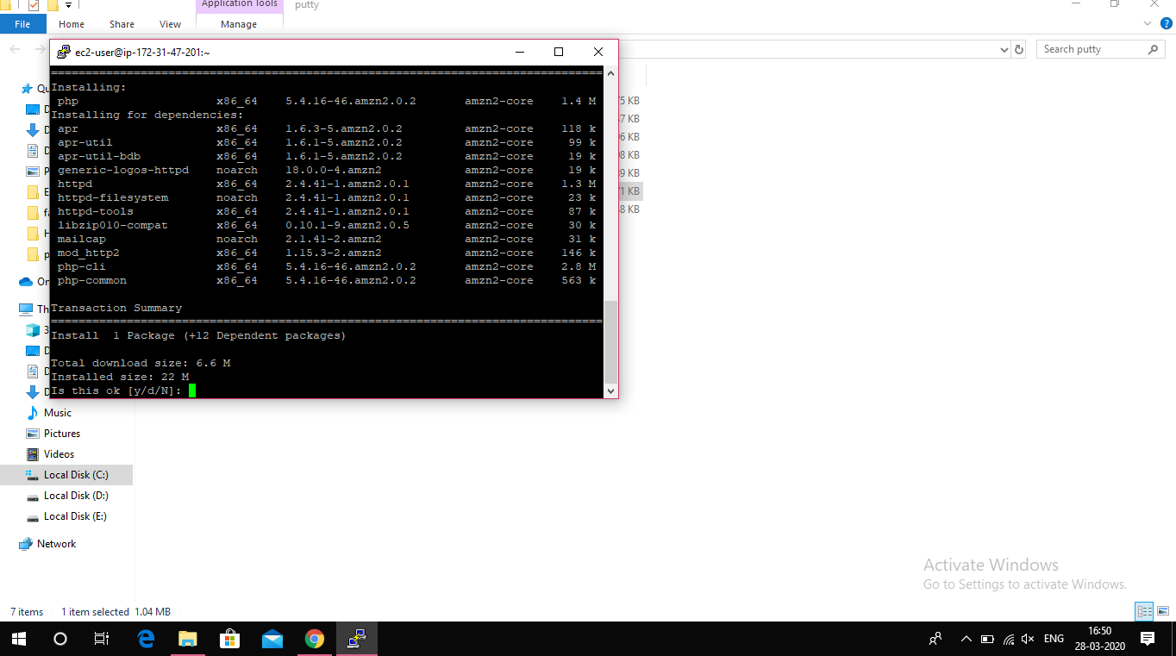

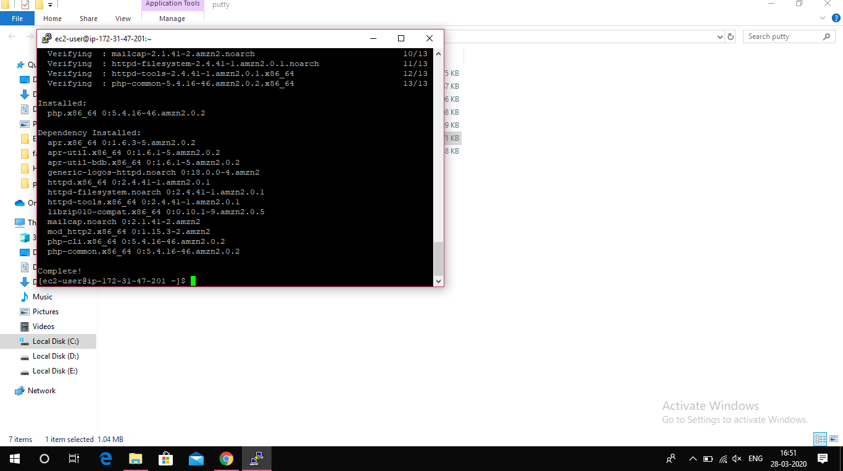

* **Installing aws-sdk:**

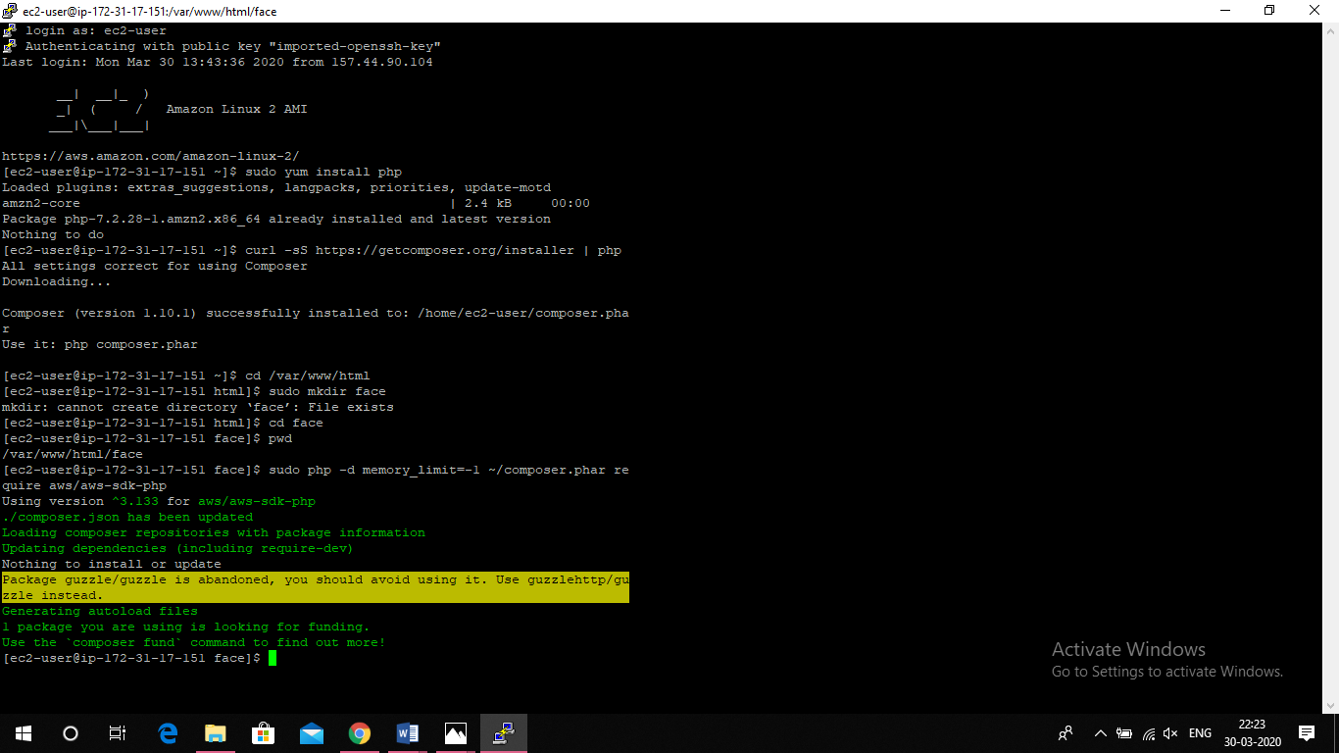

* **Index.php file upload:**

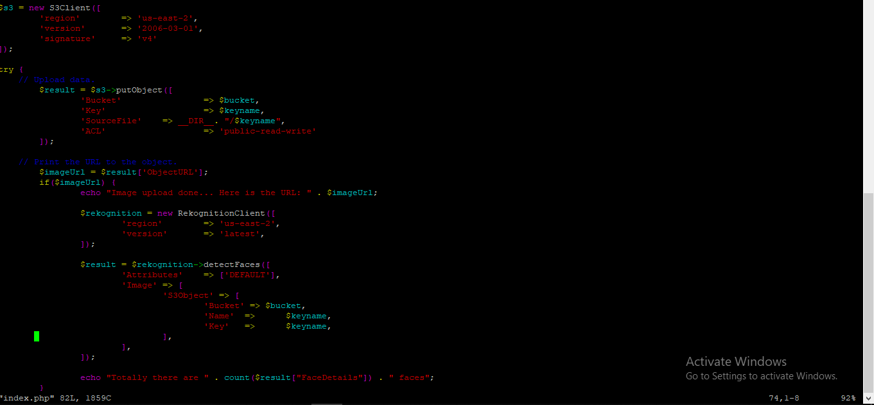

* **Image upload done:**

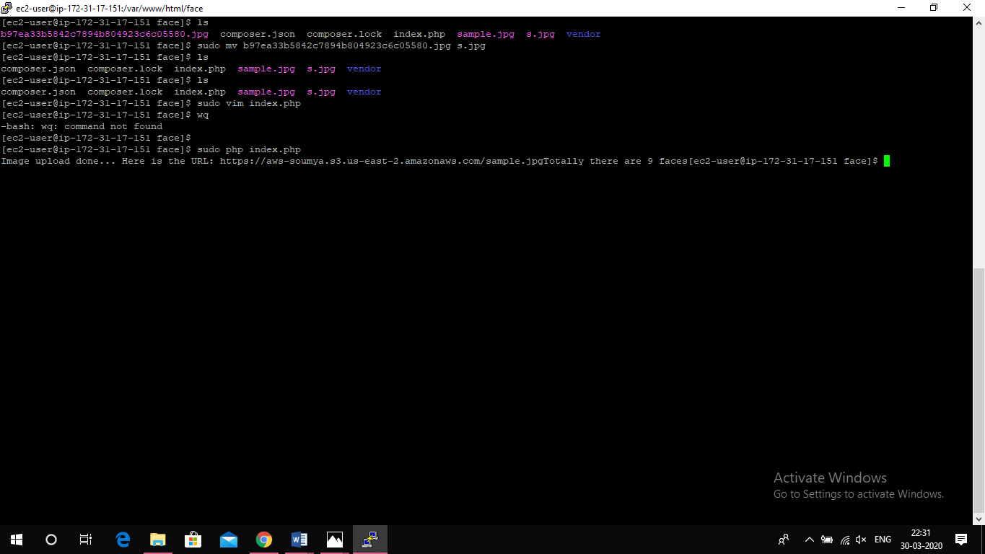

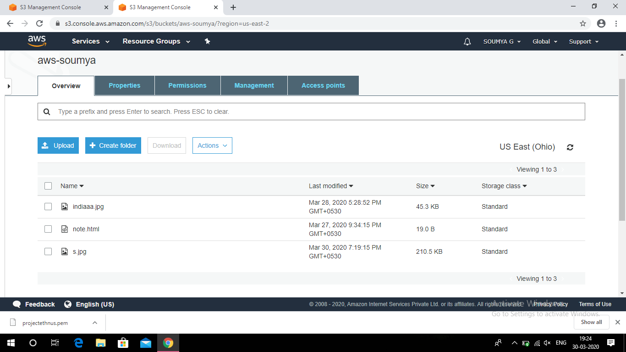

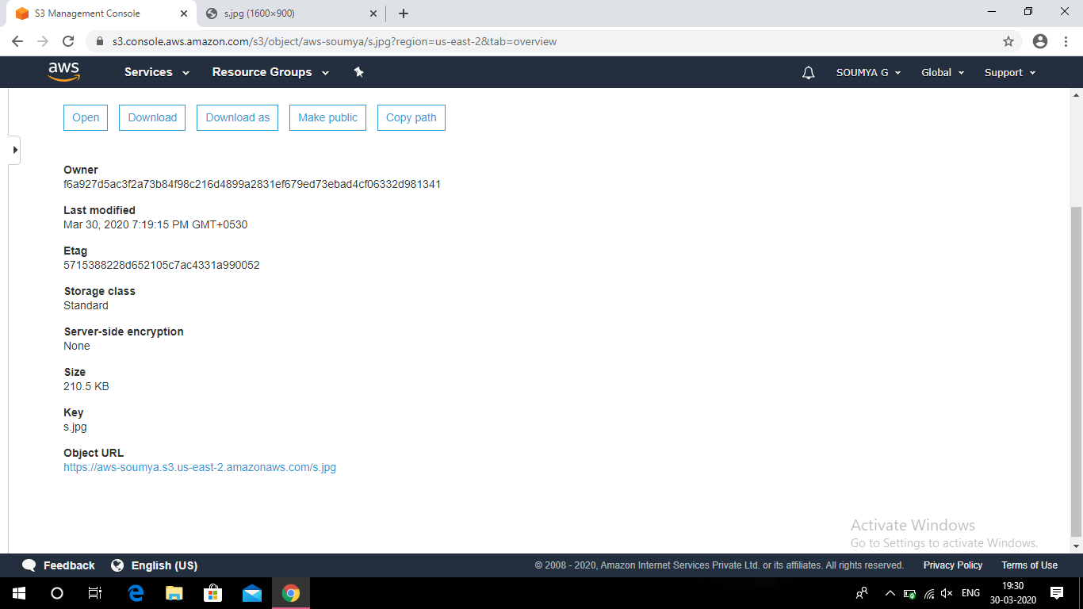

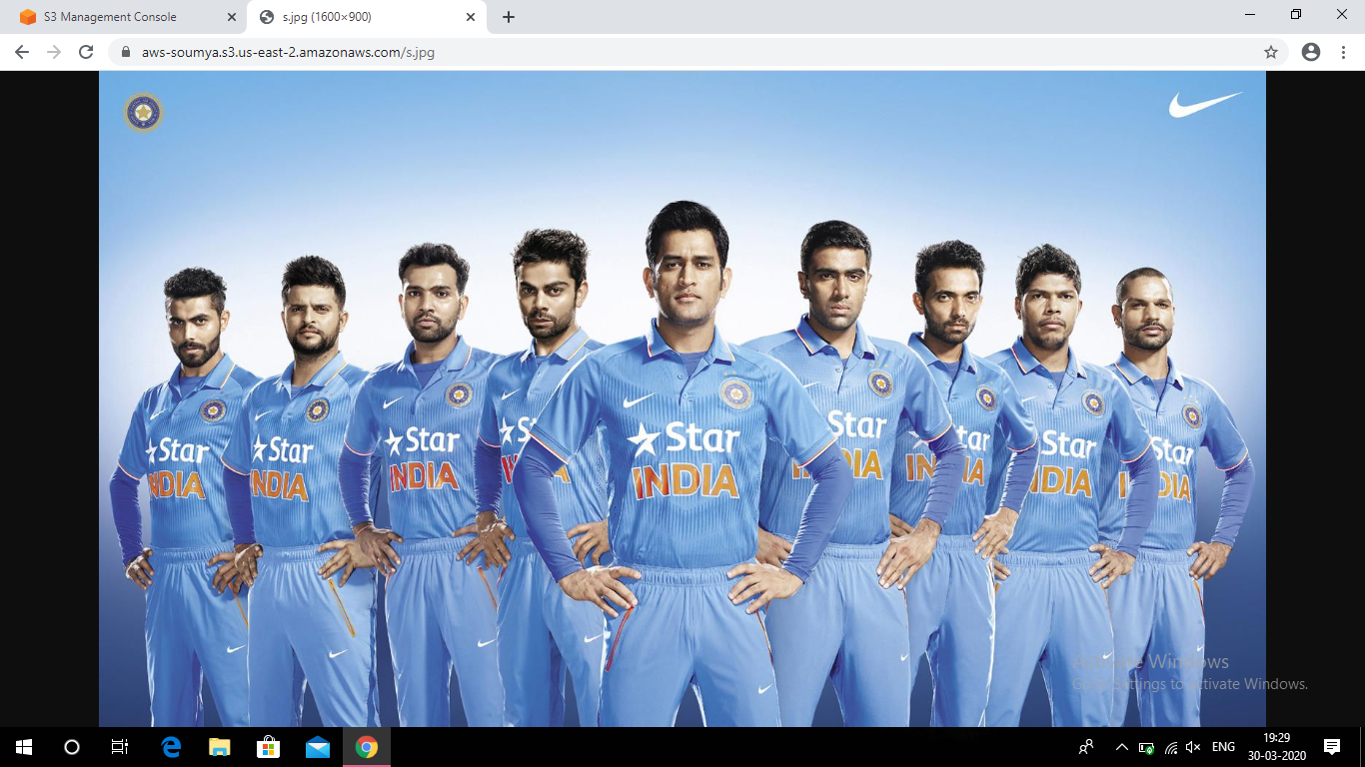

**EC2 & Rekognition:**

* **Face Detect success screenshot**

